Architecture and zoning

**Different charging stations for different use**

In the part about technology, many charging systems were introduced. Eventually, because their different technical characteristics has an impact of the potential use, they can be classified in roughly 3 categories. The level 1 charging station works on AC voltage, and is the cheapest type of charger. It requires a lot of time to charge (generally 8 hours or more). As a consequence, it is deployed only at home, or possibly at work, to charge the electric vehicle overnight or during the working day. The Level 2 charger has a lower charging time, around 4 hours for full charge. It can be used in each place where the electric vehicle owner will stay a limited but not too short amount of time, for instance in front of a cinema. The last type is the level 3, working on DC. It is currently far more expensive, and it is expected to charge the car’s battery up to 80% in 30 minutes.

**The possible places to deploy a charging station**

The main possible places for the charging stations are of 4 categories. First, it could be installed at home, in a garage. It allows the user to charge it every night when coming home, until the time he leaves the house. The trend for this kind of system is, as it is briefly introduced in the chapter about technology, to connect the charging station to the grid, in order to optimize the charging and de-charging of the car. On electricity price peak hours, energy from the car’s battery can be sold to the grid; on off-peak hours, the charging of the car at a lower price takes place. The second category is at the office parking spots. It is the second place people spend most time in. The duration of work allows to install level 1 or level 2 charging station. Third, it could be positioned in the public or private parking areas in cities. Generally, a faster charger is required because the car will not stay parked more than 2 hours in general. Lastly, some charging stations need to be places in highways rest areas. In this case, the charging should be as fast as possible, so a level 3 charging station is recommended.

**The integration of the charging station in the environment**

Charging stations need to fit in the current environment, whether it is in private areas, or public areas. At this time, many rules about the design of such charging stations have been implemented; they specify the required size, the security of the charging stations, and the minimum number of charging stations in an area. These regulations are more mature in Europe and the US, and we will consider here the US regulations. Although many of these rules are local and depend on the city, we can find the same characteristics.

Firstly, the parking spot requires a bigger size than regular parking places. Indeed, we need to take into account the place required to install the charging station, as well as the place to enable the user to operate it. Some parking structures provide opportunities for a more practical and cost effective design.

Then, the security with respect to environmental hazards should be guaranteed. For example, the chargers cannot be installed in flooding areas. What’s more, most of the charging station companies want to connect the system through modems to the Internet, to be able to give real-time information about the charger (free or not, payment…). In some places like parking spots in basement, it will be a challenge to guarantee a good network.

When choosing a place to put the charging station, one need also to take into account the need to connect it to an electrical source. It could be an independent source such as solar panels, but it can also be the public electricity network. In this fashion, the need to trench into the ground to connect the charging stations is also an issue in parking areas.

**The Range Anxiety effect**

One of the main issue that the charging station need to solve is the range anxiety. According to the paper *a study of electric vehicle charging patterns and range anxiety*, it is defined as *the fear of running out of power when driving an electric vehicle.*

Many researches have been conducted to see what the average distance a vehicle moves every way. For example, the study entitled *Electric vehicles: How much range is required for a day’s driving* has shown that for 95% of the days, the mileage does not exceed 100 miles, which makes most of the daily commuting possible without the need to charge an electric vehicle during the day (only at night at home is enough).

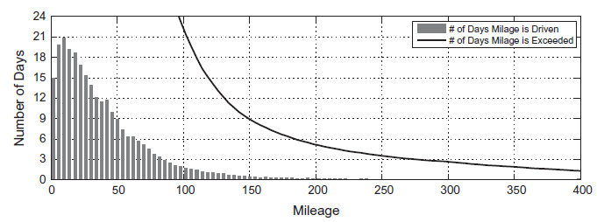

Average daily mileage distribution. Histogram of daily mileage during 148,350 driving days over a year. Grey bars show 4 miles/day bins; zero daily miles is not tabulated in the histogram. The black lines show the sum of days per year that each daily mileage is exceeded

Pearre, N., Kempton, W., Guensler, R. and Elango, V. (2011). *Electric vehicles: How much range is required for a day's driving?*. 1st ed. [ebook] Transportation Research Part C, p.1174. Available at: http://www.sciencedirect.com/science/article/pii/S0968090X1100012X [Accessed 31 May 2015].

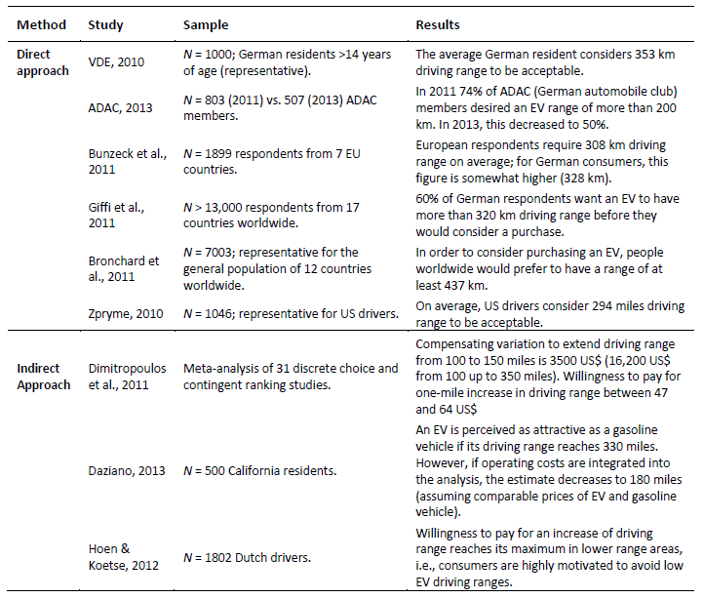

Results from previous range preference studies

Thomas Franke & Josef F. Krems, *What drives range preferences in electric vehicle users?* Transport Policy

Yet, many people today refuse to use electric vehicles because they fear they will run out of battery. They do not want to buy an electric car unless the vehicle has a very good range. For instance, 60% of German respondents want an EV to have more than 320km driving range (about the range of a regular car) before they would consider a purchase (Giffi et al.,2011).

This range anxiety effect is of paramount importance to provoke the shift from aversions for electric vehicles to a boom in the market. But it also reveals that, even if many charging stations are added in public areas in the cities, they will not necessarily be used a lot.

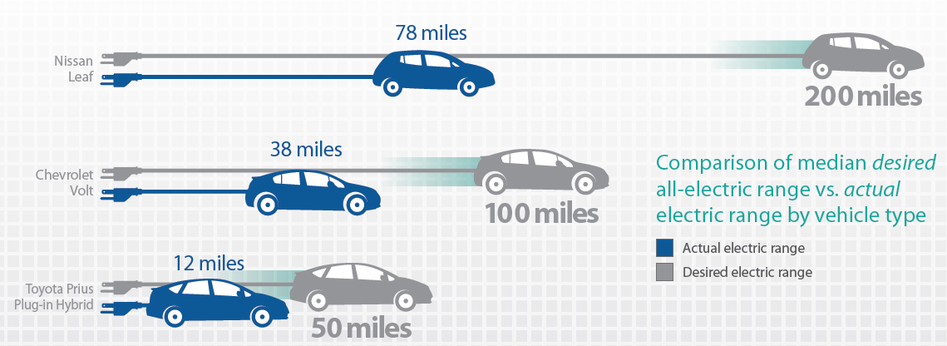

Range anxiety in California: survey

Source :

<https://energycenter.org/sites/default/files/docs/nav/transportation/cvrp/survey-results/California_PEV_Owner_Survey_3.pdf>

California Plug-in Electric Vehicle Driver Survey Results May 2013

Energycenter.org, (2015). *February 2014 Survey Report | CSE*. [online] Available at: http://energycenter.org/clean-vehicle-rebate-project/vehicle-owner-survey/feb-2014-survey [Accessed 27 May 2015].

**Quotes:**

The range anxiety is the fear of running out of power when driving an electric vehicle

most of the daily commuting is possible without the need to charge an electric vehicle during the day

daily mileage in Germany of 39 km

**Layar:**

On the graphs and illustrations

4th part 1st paragraph talk about *study of electric vehicle charging patterns and range anxiety : link : http://www.diva-portal.org/smash/get/diva2:626048/FULLTEXT01.pdf*

4th parts 2nd paragraph : talk about *Electric vehicles: How much range is required for a day’s driving : link :* <http://www.sciencedirect.com/science/article/pii/S0968090X1100012X>

4th part 3rd paragraph : https://www.tu-chemnitz.de/hsw/psychologie/professuren/allpsy1/pdf/Franke-Krems_2013_PrefRange-AAM.pdf

**Reference:**

Bakker, J. (2011). Contesting range anxiety: The role of electric vehicle charging infrastructure in the transportation transition. 1st ed. [ebook] Eindhoven: University of Technology Eindhoven. Available at: http://alexandria.tue.nl/extra2/afstversl/tm/Bakker_2011.pdf [Accessed 31 May 2015].

Franke, T. and Krems, J. (2013). What drives range preferences in electric vehicle users?. 1st ed. [ebook] Transport Policy. Available at: https://www.tu-chemnitz.de/hsw/psychologie/professuren/allpsy1/pdf/Franke-Krems_2013_PrefRange-AAM.pdf [Accessed 31 May 2015].

Haugneland, P. (2014). Norwegian electric car user experiences 2014. 1st ed. [ebook] European Electric Vehicle Congress, Brussels, Belgium, December 2014. Available at: http://elbil.no/elbilforeningen/dokumentarkiv/finish/10-dokumenter/382-norwegian-electric-car-user-experiences-2014 [Accessed 31 May 2015].

Knutsen, D. and Willén, O. (2013). A study of electric vehicle charging patterns and range anxiety. 1st ed. [ebook] Uppsala Universitet. Available at: http://www.diva-portal.org/smash/get/diva2:626048/FULLTEXT01.pdf [Accessed 2 Jun. 2015].

Mayfield, D. (2012). Site Design for Electric Vehicle Charging Stations. 1st ed. [ebook] Sustainable Transportation Strategies. Available at: http://publicservice.vermont.gov/sites/psd/files/Quick_Links/Transportation_LandUse/Goal1/NYSERDA%20Site-Design-for-EV-Charging-Stations_7%2019%2012.pdf [Accessed 31 May 2015].

Pearre, N., Kempton, W., Guensler, R. and Elango, V. (2011). Electric vehicles: How much range is required for a day's driving?. 1st ed. [ebook] Transportation Research Part C, p.1174. Available at: http://www.sciencedirect.com/science/article/pii/S0968090X1100012X [Accessed 31 May 2015].

Schroeder, A. and Traber, T. (2012). The economics of fast charging infrastructure for electric vehicles. 1st ed. [ebook] Energy Policy. Available at: http://www.sciencedirect.com/science/article/pii/S0301421511010470 [Accessed 31 May 2015].

What drives California's plug-in Electric vehicle owners?. (2013). 1st ed. [ebook] Available at: http://energycenter.org/clean-vehicle-rebate-project/vehicle-owner-survey/feb-2014-survey [Accessed 1 Jun. 2015].

Zhang, N. (2014). Allocation Strategy for Tesla's Charging Stations in Beijing CBD. 1st ed. [ebook] Available at: http://www.barrywaite.org/gis/projects/fall-2014/Zhang-Nuobei-PPD%20631%20GIS%20-%20Revised.pdf [Accessed 31 May 2015].

Annexe:

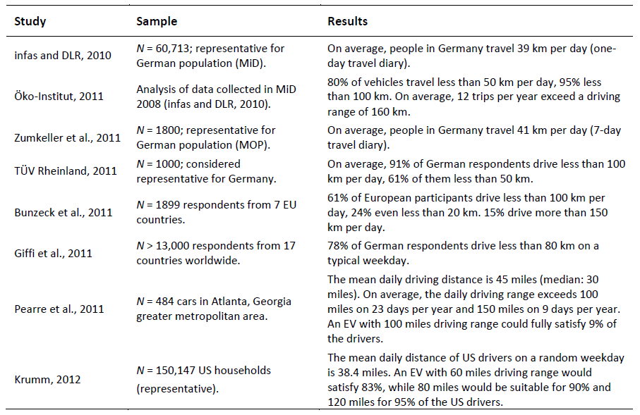

Results from previous range preference studies

Thomas Franke & Josef F. Krems, *What drives range preferences in electric vehicle users?* Transport Policy

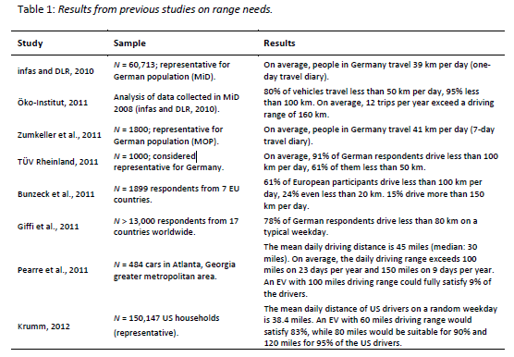

Results from previous range preference studies

Thomas Franke & Josef F. Krems, *What drives range preferences in electric vehicle users?* Transport Policy